

**Rabiammal Ahamed Maideen College for Women**

**Bachelor of Science in Mathematics**

**Team Members:**

**K.Rajumitha**

**M.Sivaranjani**

**S.Sivaranjani**

**Umairah Mohammed**

**iRevolution: A Data-driven Exploration of Apple's iPhone Impact in India**

**Team ID: NM2023TMID13550**

**Introduction**

Our project is an exploration of apple’s iPhone impact in India involving the collection and analysis of a wide range of data using the analysis tool Tableau.

PROBLEM DEFINITION & DESIGN THINKING

Empathy map

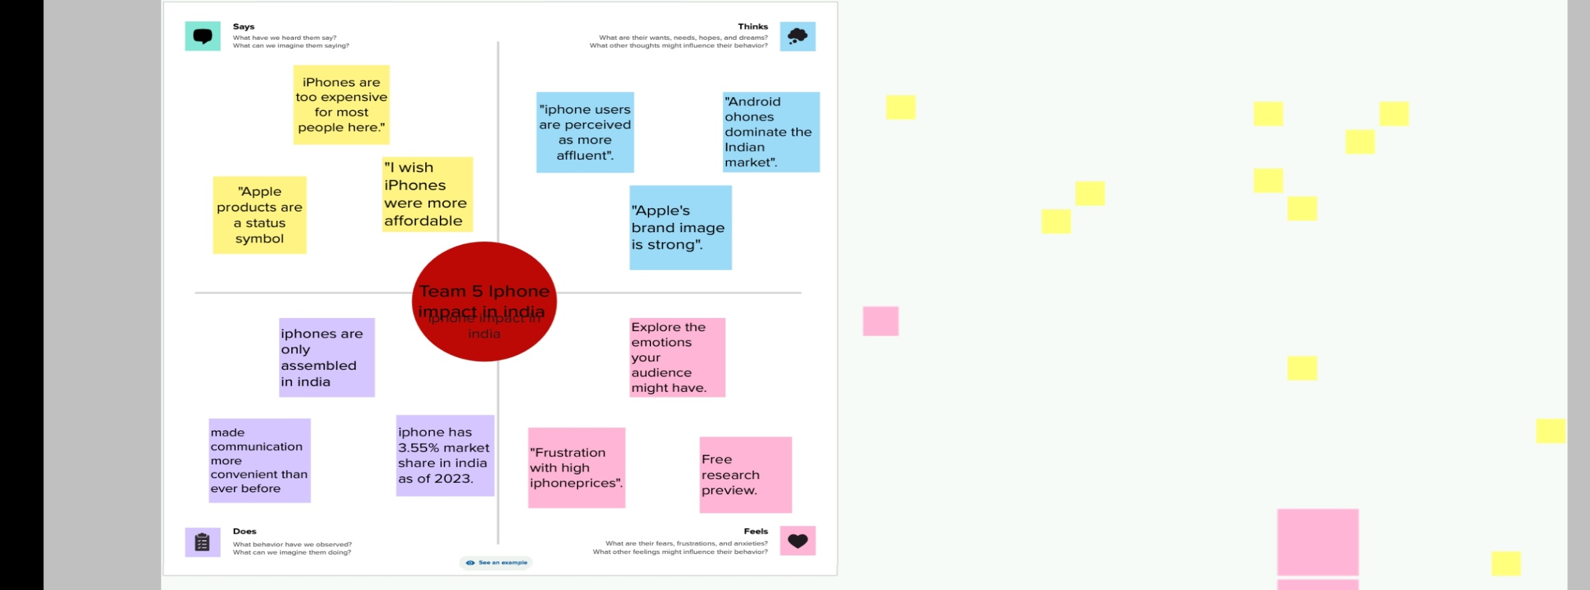

Ideation & Brainstorming Map:

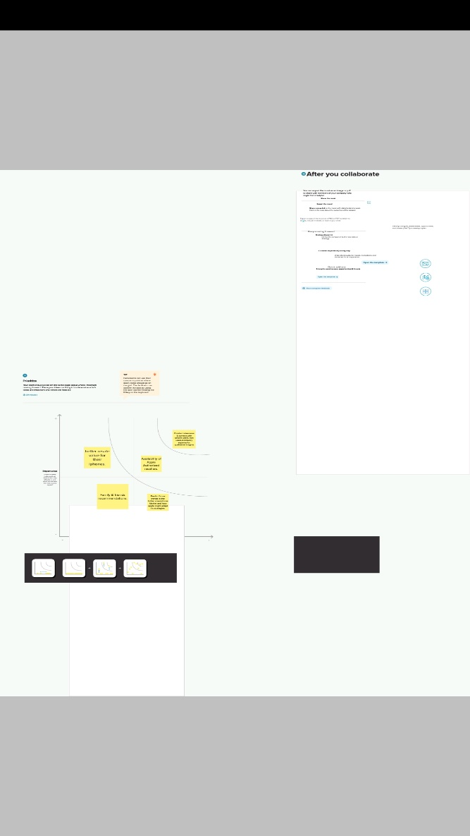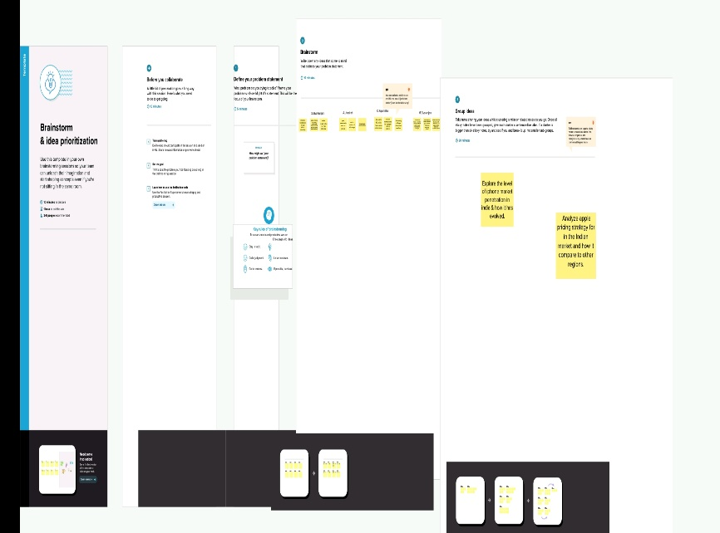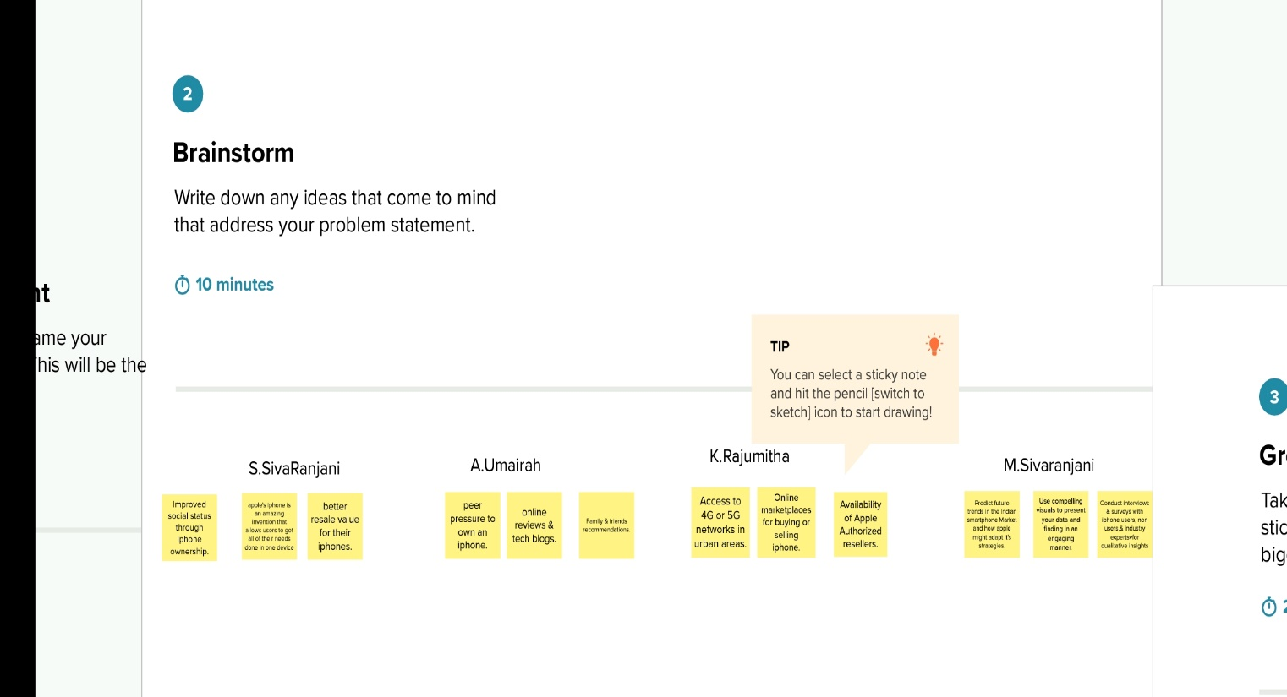

**KPI**

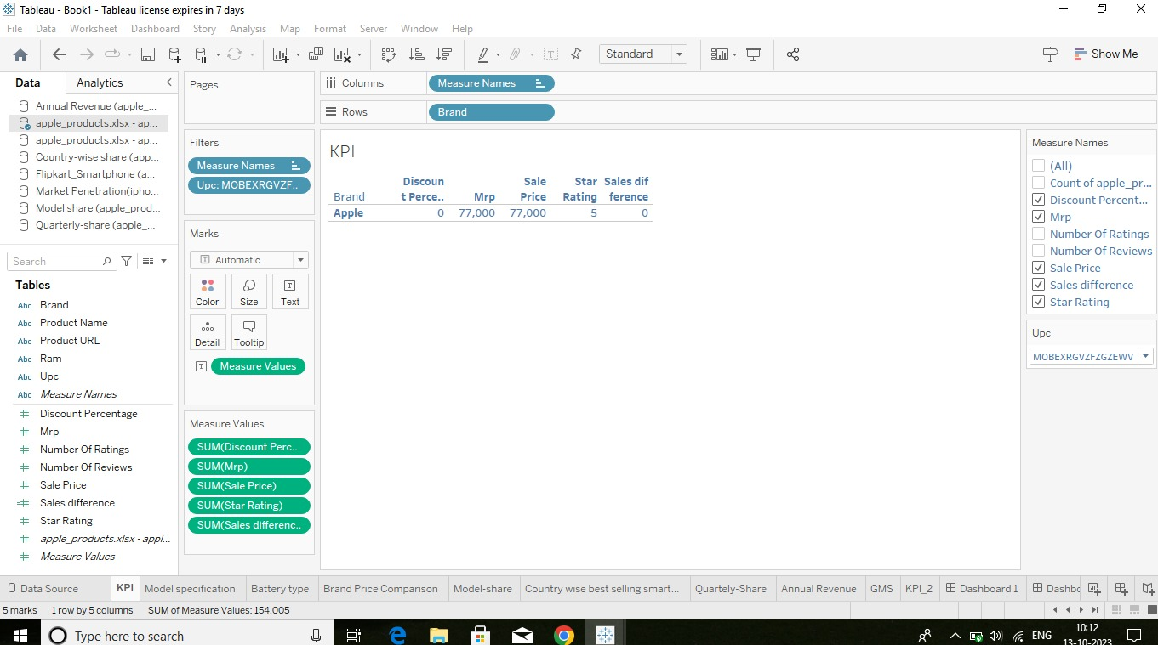

**MODEL SPECIFICATION:**

The analysis of the flip-kart smartphones contains the model, which processor are used, rear camera and original price of the apple iPhone.

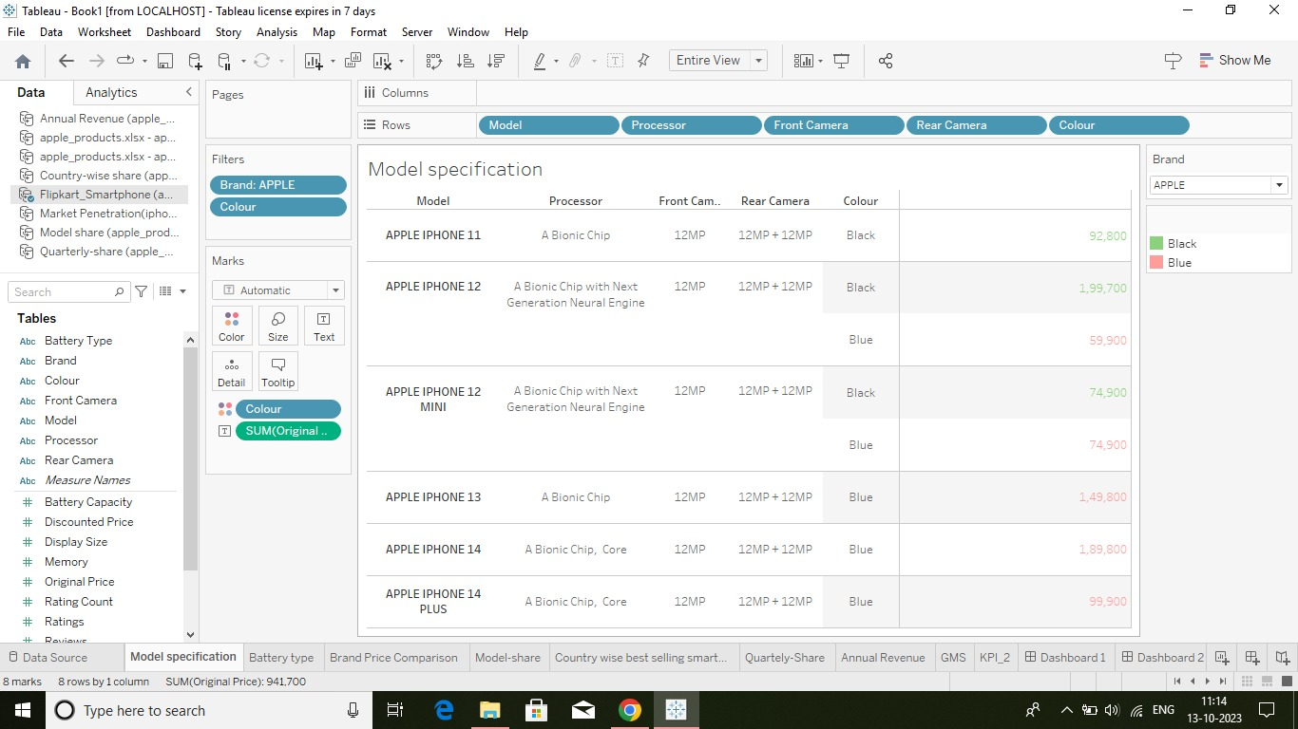

**BATTERY TYPE DISTRIBUTION:**

In the analysis Lithium battery has a highest price such as 35k compare to other batteries.

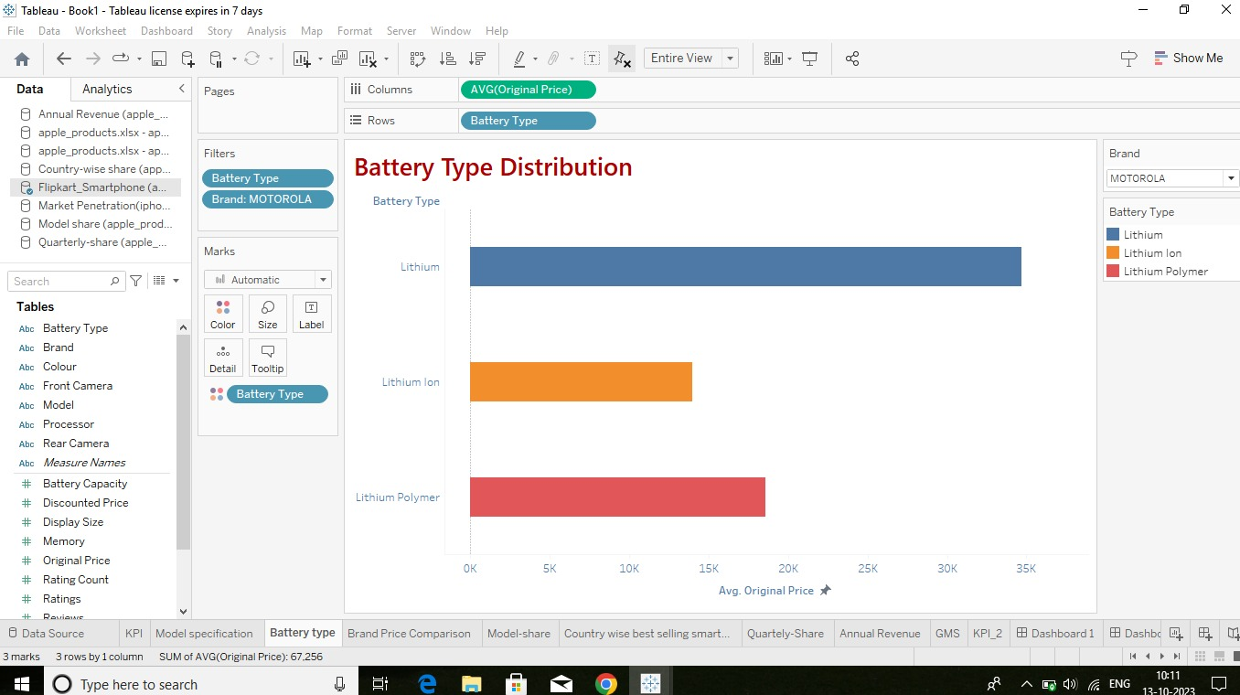

**BRAND & PRICE COMPARISON:**

Apple phones are compared to other company models with the price and memory. Companies like Oppo, RealMe, Vivo and etc…..

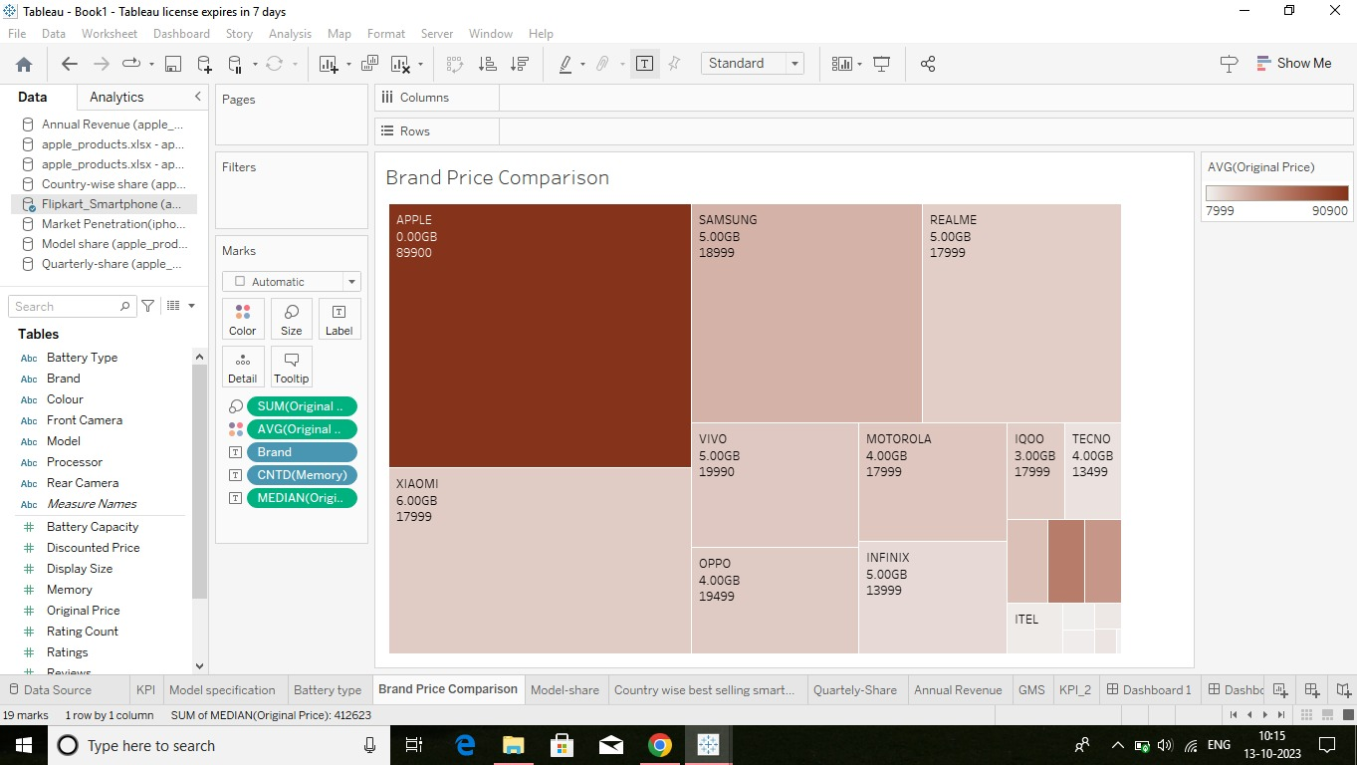

**MODEL-SHARE:**

Apple phones has a various models based on the internal storage, RAM, ROM, camera quality and others…

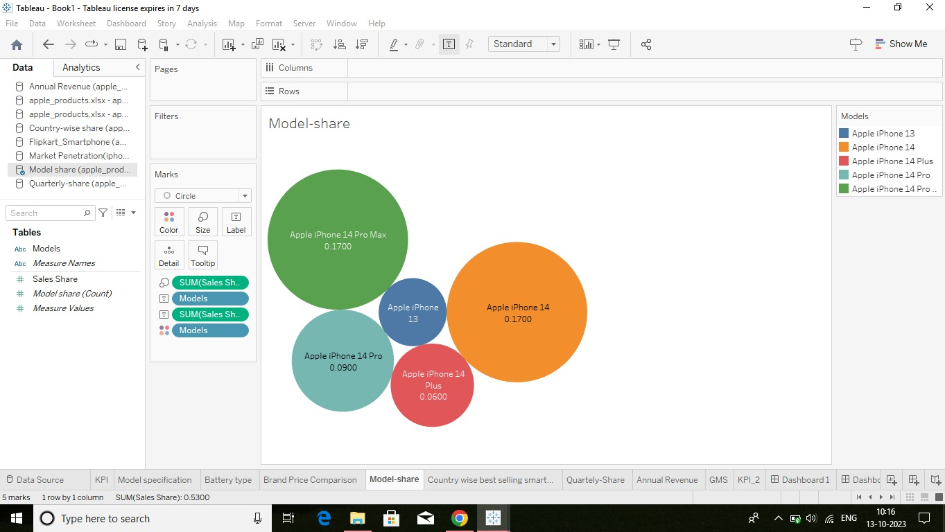

**COUNTRY WISE BEST-SELLING SMARTPHONES:**

In India apple iPhone has a 3.00% of sales share. Apple iPhone has third place in sales-share. OnePlus has the first place in sales-share (4.00%) of India.

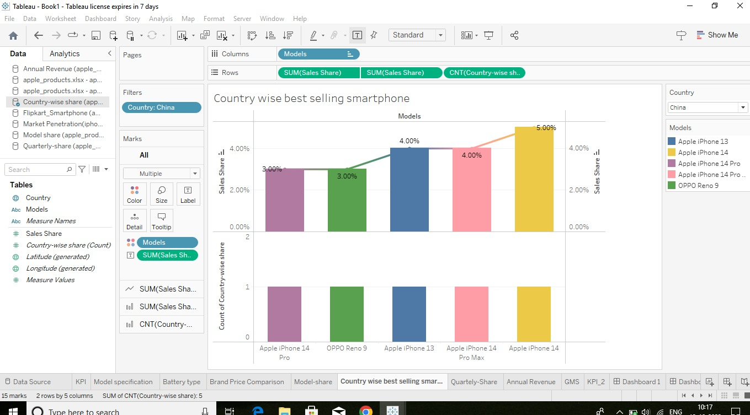

**QUALITY-SHARE:**

In 2018 we will analysis the quality-share of mobile company models. The year will be changed manually.

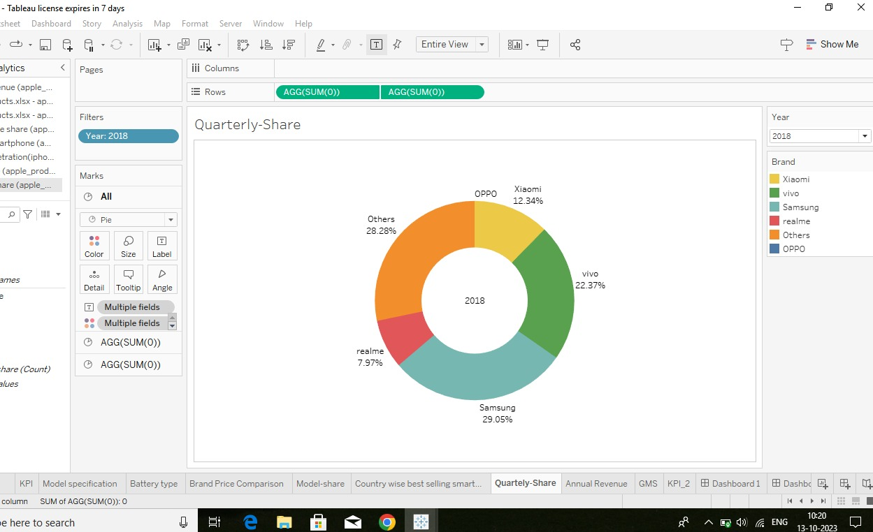

**ANNUAL REVENUE:**

Apple iPhone sales generated $ 205 billion revenue for Apple in 2022, more than Microsoft’s total revenue. It sold 232 million iPhone units that year. 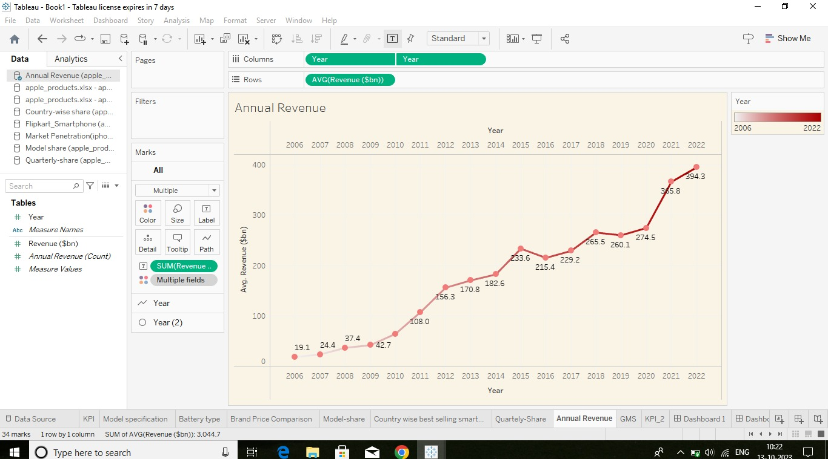

**GLOBLE MARKET SHARE:**

Although the iPhone isn’t far behind in the competition, it is yet to scale-up its marketing strategies and policy formulations for Indian audience.

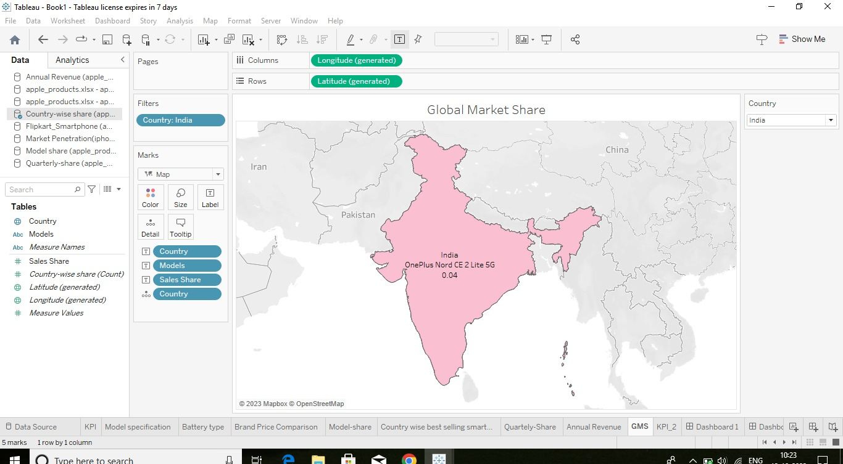

**KPI 2**

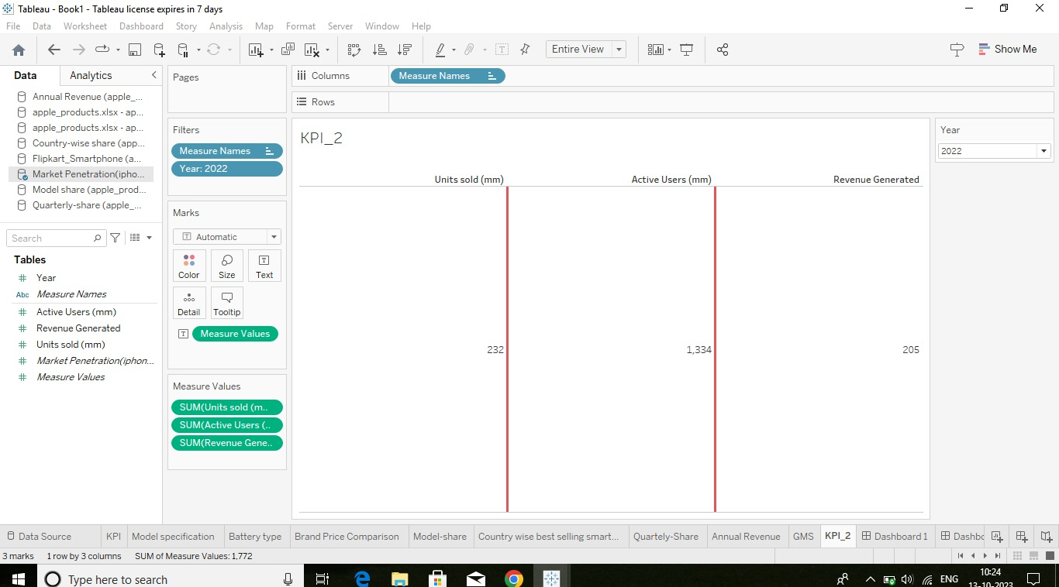

**DASHBOARD:**

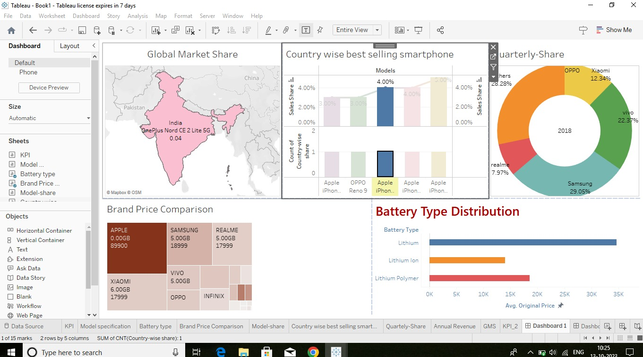

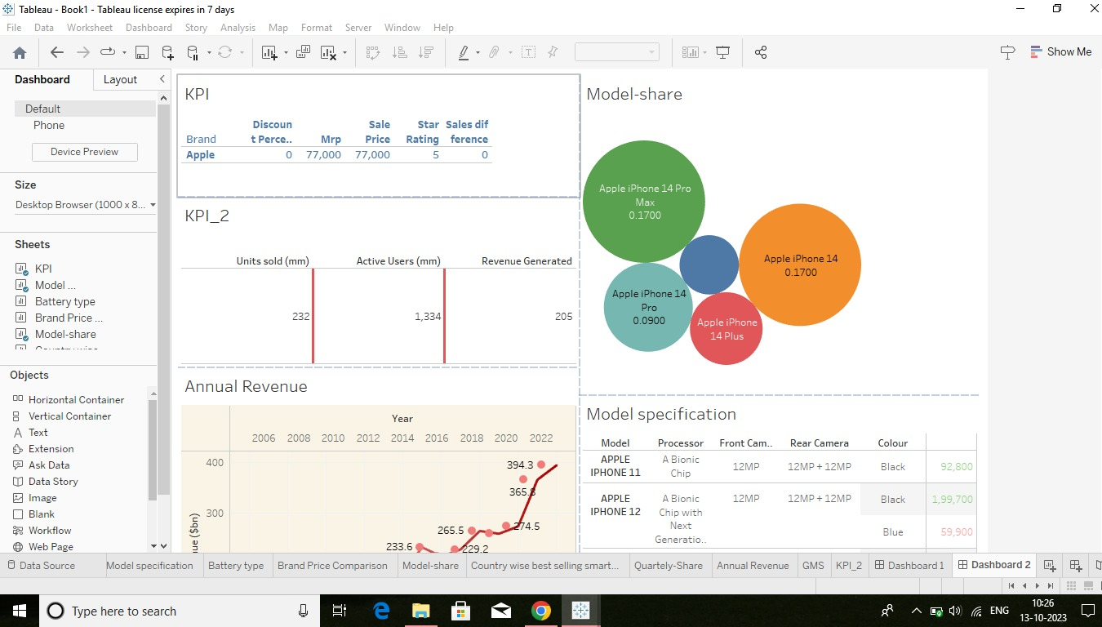

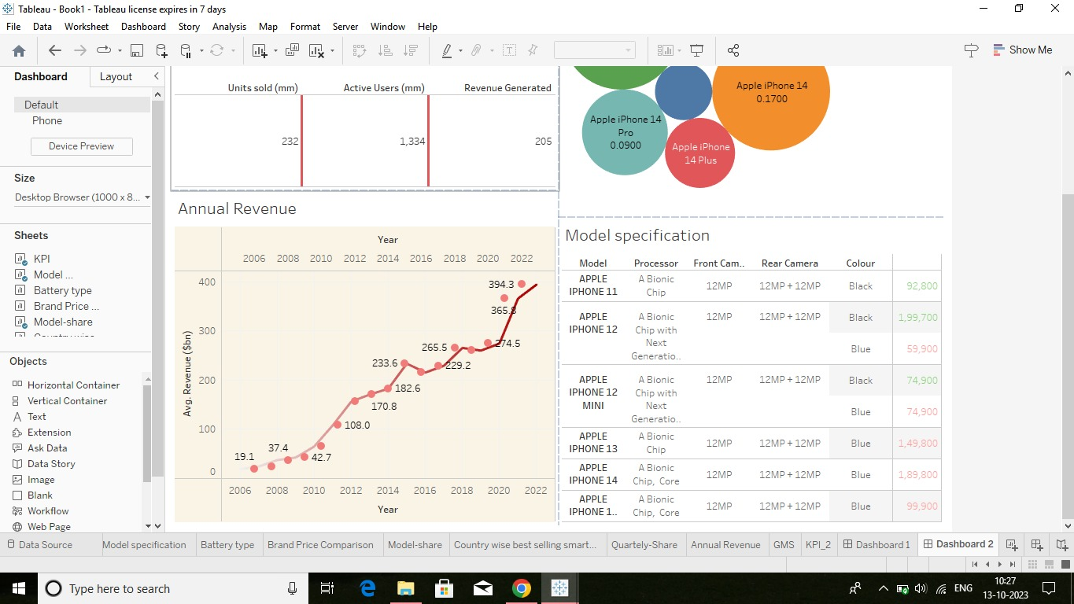

**STORIES:**

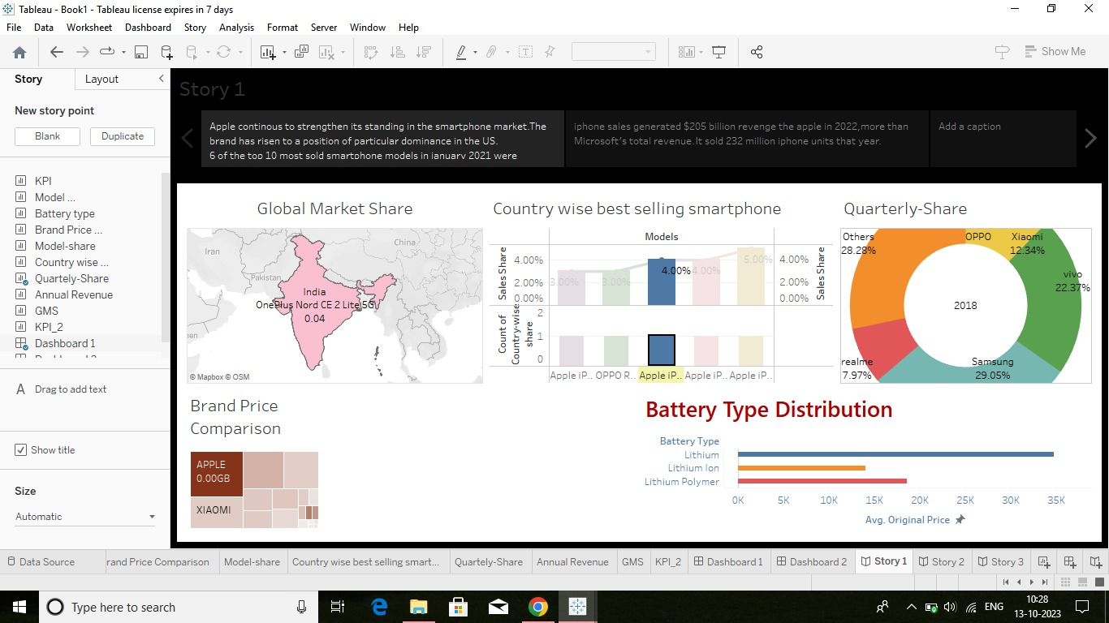

**ADVANTAGES & DISADVANTAGES:**

**ADVANTAGES:**

* Better performance compares to android devices, apple phones offer better performance.
* The iPhone is better than android, offering timely and instant updates to the users.
* Another advantage of apple iPhone over android is the ease of use.
* All apps available in the apple iPhone store go through strict checking.
* The family sharing feature also makes iPhone better than android.

**DISADVANTAGE:**

* Android phone dominate as more affluent.
* Limited access on the apple store.
* Software updates consuming too much data.
* Examine the economic impact of iPhone sales on Apple its suppliers and the Indian economy as a whole.
* iPhone are too expensive for most people here

“I wish iPhone were more affordable.”

**CONCLUSION:**

This analysis gives the details to find the impact of apple iPhone in India. This helps us to compare Apple iPhone to other company models. It’s sales-share less rather than other companies. I t was help us to analysis the impact of apple iPhone in India.

**FUTURE SCOPE:**

After android. iOS is the most extensive mobile operating system. It will have a market share of 277.73% in 2022, gradually increasing due to the popularity of iPhone. As the demand for Apple devices is rising the iOS development market is simultaneously booming.

**APPENDIX**

Source code Attach for the solution built.

<https://public.tableau.com/app/profile/rajumitha.k/vizzes>

<https://github.com/SivaRanjani38/iphones_impact_in_india>